Soviet Red Star Armoured Railcar

I had been working on a N-Scale model of the Soviet prototype armoured railcar Красная звезда (Krasnaya Zvezda) or Red Star built at Luhansk works during winter 1941/42. Although only a protype was constructed, it does make, I think, an attractive model. Development of the model has stopped as I cannot find a suitable motorised chassis to fit; work on a printed drive train has proven to be too time consuming at present. I publish work to date in the hope that some will find it useful. The body is complete apart from some rivets and handles which ought to be fitted. This is to be considered a Work In Progress.

The prototype was built using what resources were to hand as the locomotive works were stripped of most machine tools to avoid capture by the invaders. Luhansk was involved in tank repairs at the time. Thus a spare KV-1 tank turret was used, two diesel motors – one for forward direction and the other for reverse as no suitable gearbox could be constructed. The bogies were chain driven by the motors. The body internals were constructed from what appears to be welded I beams and some castings. A better description and (poor) prototype photos are available at Project armored cars "Red Star" though caution should be used if accessing this hyperlink.
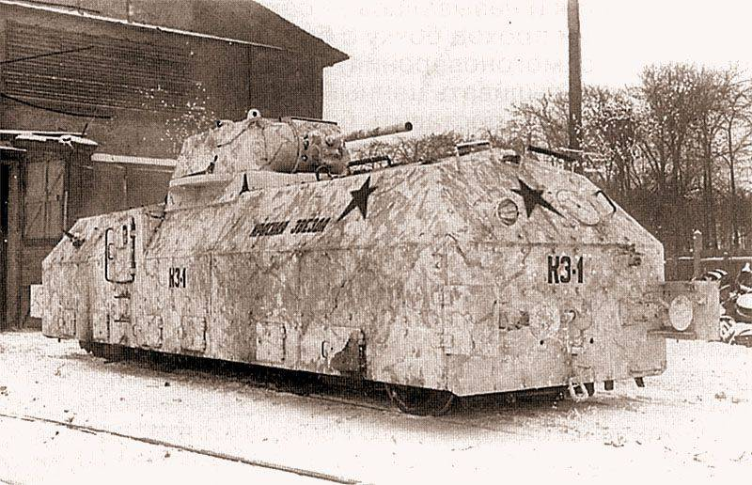
Using an accurate caliper against the scale drawings and known measurements (e.g. track gauge of 1524mm) it has been possible to rescale the dimensions of the model from the drawings (which were not a regular train or plastic kit scale). I have used Openscad to develop the drawings into a fairly complex design due to angles. Like my other designs, I provide most dimensions in a separate parameters file to reduce magic numbers.

I have imported and rescaled an already available good KV-1 (Kliment Vororshilov) tank turret.

I used dark grey PLA to print the body and turret using a Prusa Mk3S+ with a 0.2mm nozzle. My intention was to purchase the chassis, bogies, motor and gears as a prebuilt unit. With no suitable unit I know of, I started work on a motor block, chassis and bogies using PETG for the print. The design would embody a motor, flexible drive shaft and gears from Tramfabriek. It was the intention of using a tiny DCC decoder for control. Internal space is extremely limited in N-scale.

I would welcome advice on chassis construction which is limiting my progress.

